- All food items print to the remote printer named “Kitchen”. If this needs a different name, please let me know

- All items can be further modified by selecting “Modify Item” and links to the “Food Preps” modifier group.  When an item is on the virtual check, you can select the item and then select “Modify Item”.  Please look over the “Food Preps” list and let me know if anything else needs to be added. | 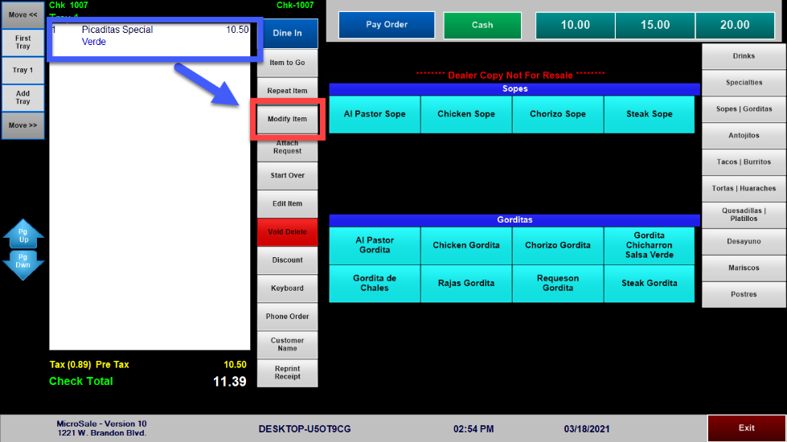  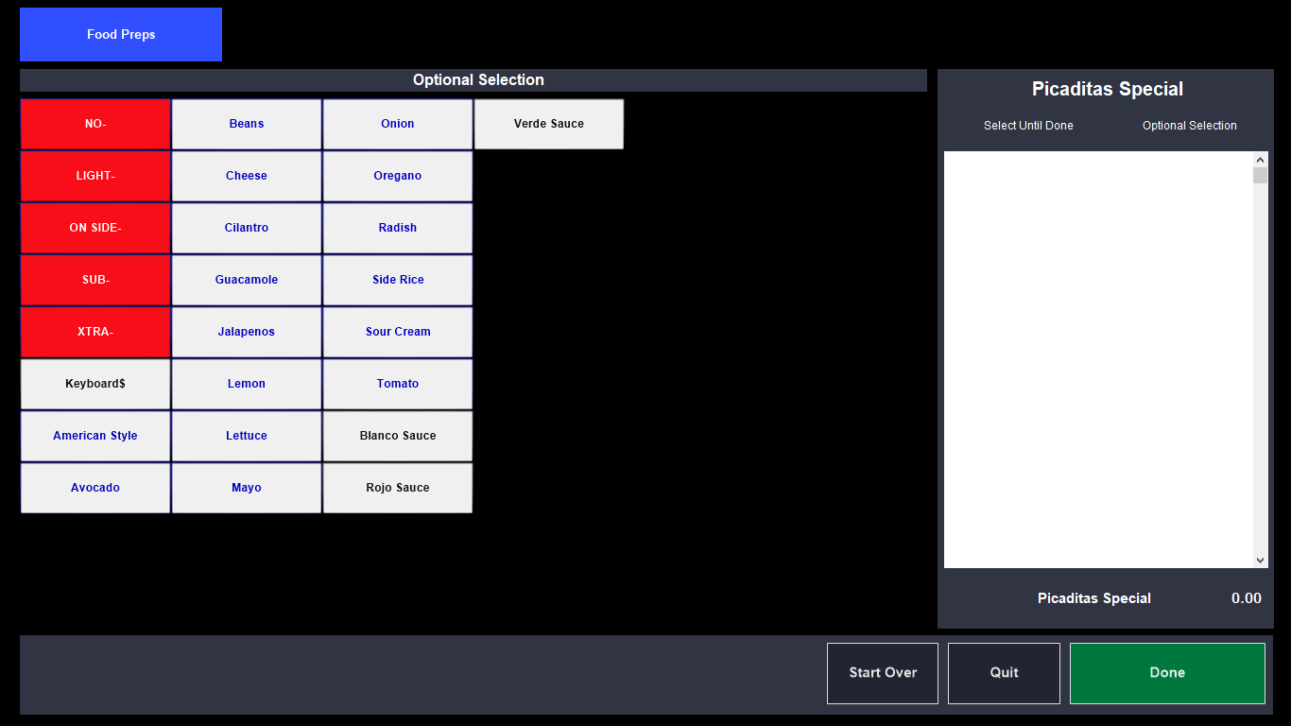

Drinks  All drinks listed on the website are listed  – currently, they are not set to print to a remote printer. | 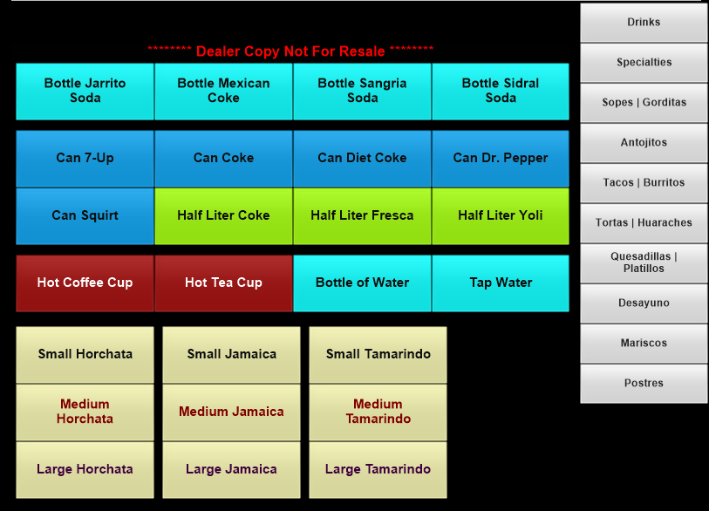
Specialties  - Menudo is set to a “Timed Event” and can only be entered on weekends  - All items prompt a Sauce Choice  - Again, you can select Modify Item to further modify with lettuce, tomato, add jalapenos, etc. | 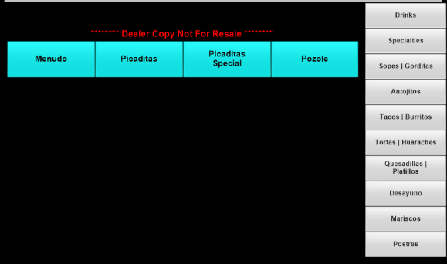
Sopes | Gorditas  - The menu did not specify if any of these items come with a side choice. If it needs one, please let me know | 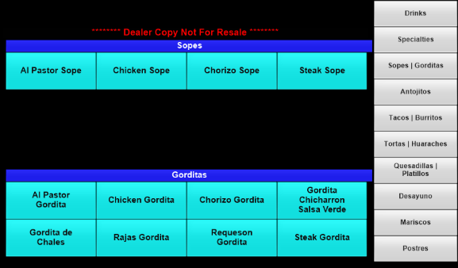
Antojitos  - Nachos con Carne prompt for a meat choice  - Chicken Fingers and Fries prompts for a side choice (shows Fries as the default option) | 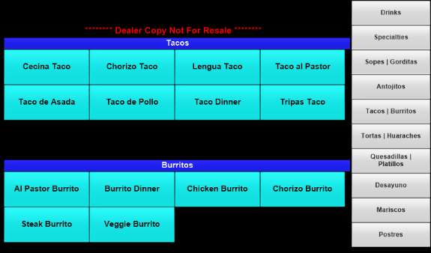
Tacos | Burritos  - All of the tacos prompt for tortilla type (flour, corn, or handmade corn for $1 extra) | 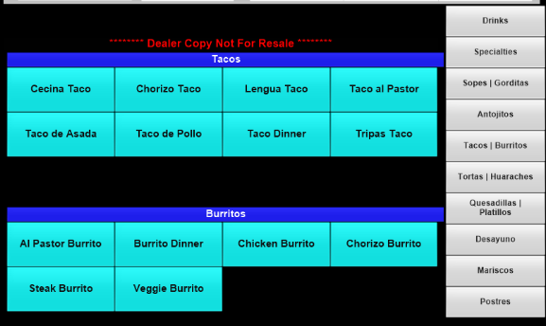
- The Taco Dinner prompts to pick 2 tacos; for quick order entry, all options are on one screen, separately by column and color. Example, you can choose 1 Al Pastor with Flour and 1 Chicken with handmade corn tortillas for $1 more | 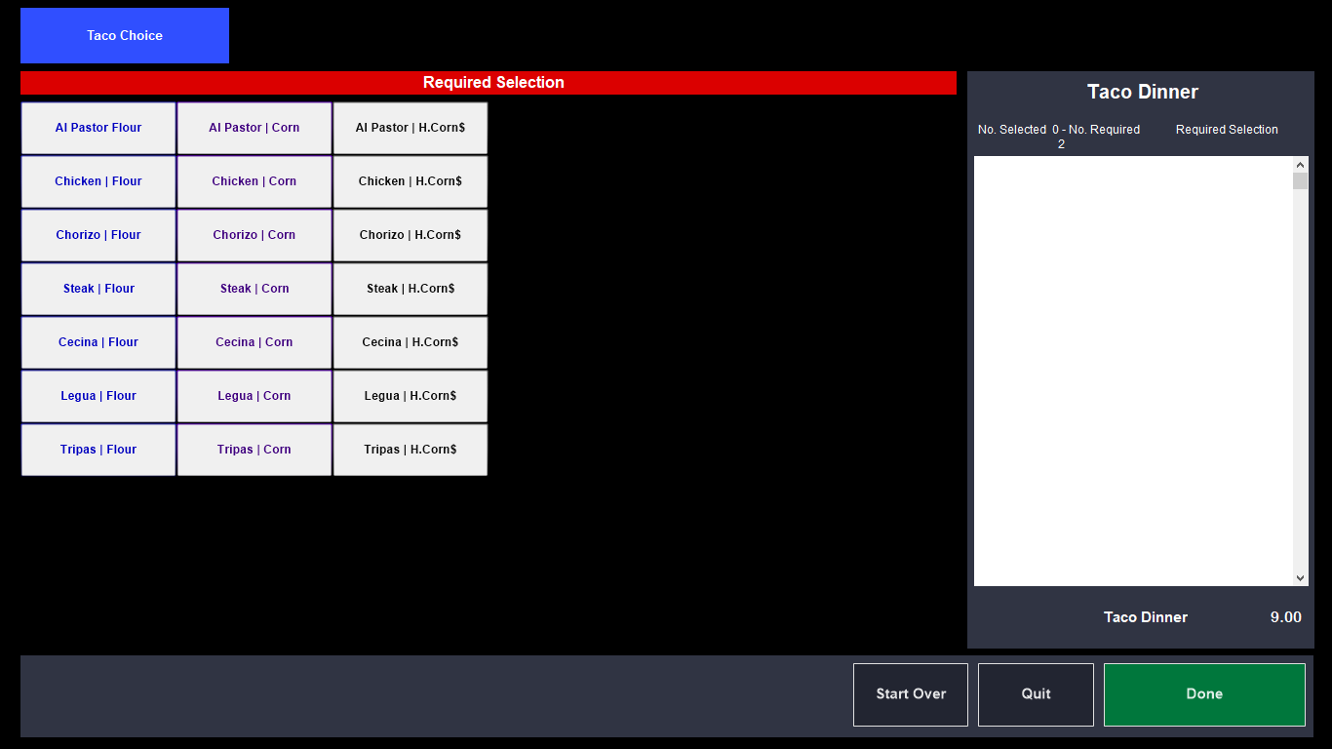
- The Burrito Dinner is setup similarly. You can choose 2 burritos and then your side option; showing Rice/Beans as the default choice | 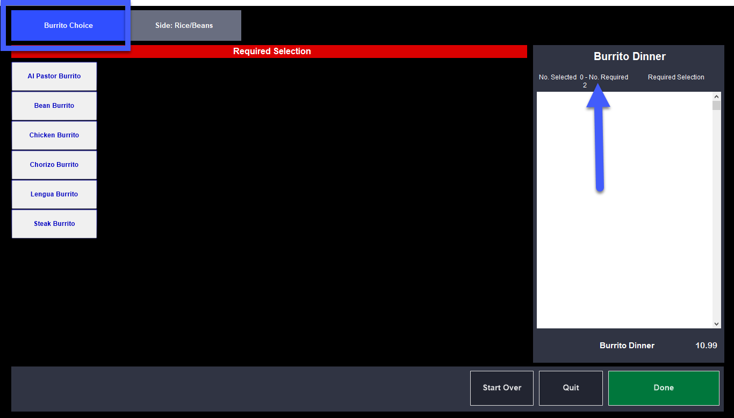
Second modifier group – side choice | 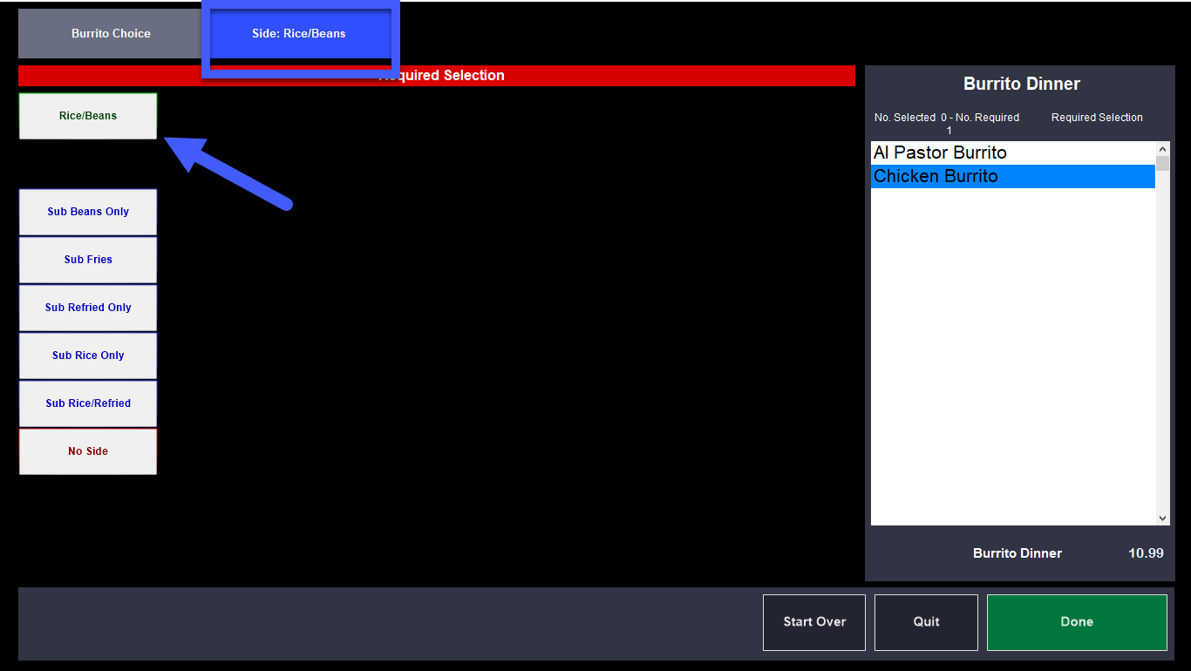
Tortas | Huaraches  - All Tortas come with a side option of fries (prompts with fries as the default option, but you can sub out the fries for something else) | 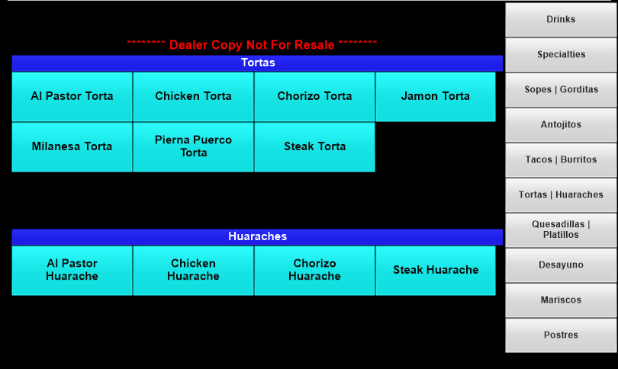
Quesadillas | Platillos  - Quesadillas prompt tortilla type (per menu)  - The Carne Asada Platillo prompts for meat temp and followed by side choice (side/beans are the default)  - All Platillos prompt side choice of rice/beans as the default | 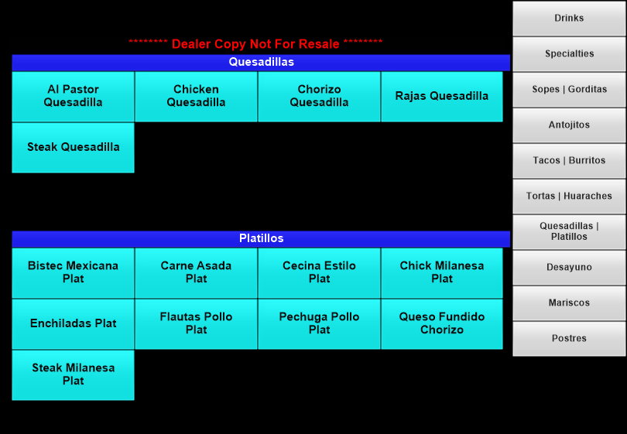
Desayuno  - Breakfast options prompt for “Egg Prep”, it stays on the screen until you select “Done”, because there is an Add Cheese option; example, Scrambled Add Cheese $.50 | 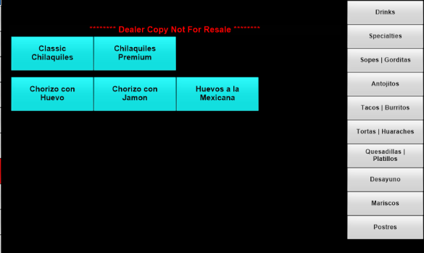
Mariscos  - It looks like all but Camarones Cucaracha and Coctel offer 2 side choices (Rice/Salad as the default) | 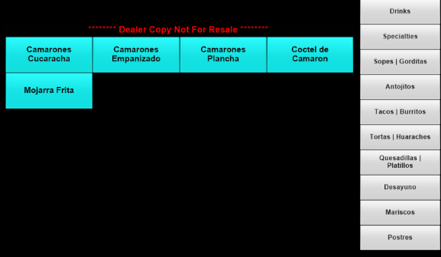
Postres  - The desserts do not prompt modifiers; however these can all be modified using “Modify Item” | 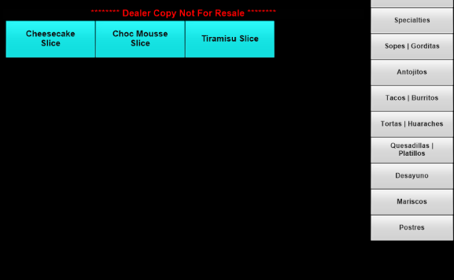

Discounts
- Generic discounts are listed until we receive the list;
- 10% off check
- 100% comp items (multi-select discount to choose as many items as you want to discount)
- 50% Employee
- Open $
- Open % (off check)
- Open % (multi-select discount to choose as many items as you want to discount)

