Function INI Import 10.0.600
The Functions.ini will no longer be needed. The functions and settings found in that will now be stored in the MSaleDataSQL database.
If upgrading an existing site to this version of MicroSale, you will import the functions.ini by going to Managers Menu Register Setup terminal Configuration Register Options Email-Export-INI Import Misc. Functions.
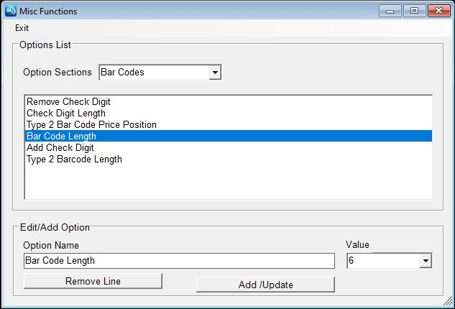
To access the functions to make changes you will go to Registers Options Email-Export-INI Misc Functions to open the Window shown above.
To make a setting change to one of the items found in the Misc Functions area please follow these steps:
- Click the “Options Sections” drop-down menu at the top of the window to select the Function category you would like to filter to. In the example above we selected “Bar Codes”. This will populate all settings found under that category.
- Select the setting you wish to alter. In this example we selected “Bar Code Length”. This will populate the “Option Name” and Value” fields.
- The Value Field is where changes are made.
  - Most of the settings will just be “Enabled” or “Disabled” selections.
  - For settings such as our example “Bar code Length” you would simply type in the value you wish to give it. In this example “6”.
- After your setting change has been made click on the “Add/Update” button to save the changes

To Remove a setting change to one of the items found in the Misc Functions area please follow these steps:
- Click the “Options Sections” drop-down menu at the top of the window to select the Function category you would like to filter to. In the example above we selected “Bar Codes”. This will populate all settings found under that category.
- Select the setting you wish to alter. In this example we selected “Bar Code Length”. This will populate the “Option Name” and Value” fields.
- Click on the “Remove Line” button to erase the line from the file.

